Joplin

Association for the

blind
  - Volume 1/Issue 2
A Recent Success
A gentleman and his wife came by the office recently to see if we had anything that could help him read. His wife can’t read so he was in desperate need of assistance to be able to read their household bills. We tried several different magnifiers to no avail but when we tried the electronic reader that connects to a television it was very successful for him. As such he purchased one and we were able to assist with setting it up in his home.

upcoming events
Our Fall Chili and Vegetable Soup Fundraiser and Silent Auction is coming up on November 9, 2023.
Lunch will be served from 11AM to 2PM
Dinner will be served from 4PM to 7PM.
Cost $8 Adults and $4 for children under 12

Carry out will be available and pre-sale tickets are available on our Facebook Page.
We will also have nuts to sell! Please join us and make a difference for your community!
“The people at the Joplin Association for the blind are the greatest people. They help you in any way that they can. When I first became blind I had lost my employment and everything as a result of losing my sight. They helped me pay my gas back and forth to Oklahoma City for at least 5 or 6 trips to see a specialist there at the University Hospital. I cannot thank them enough. If it hadn’t been for their help I don’t know what I would have done. I’m pretty sure I would not have my vision today. Because of the Association for the Blind I do have my vision today.”-Shawnya Fisher

A Word from our director
The Association provides lunch every Tuesday for the blind & visually impaired members of the Joplin Service Club of the Blind.
They enjoy the time that they're able to get out and visit with others so they don't feel so lonely and isolated.
They're always looking for new members to join their group, so if you know anyone who might be interested to please contact
us at 417-623-5721.

Mission statement:
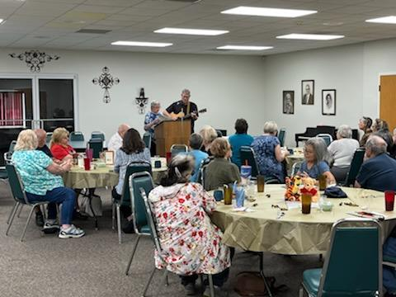

Contact Us
Joplin Association for the Blind
311 Schifferdecker
Joplin, MO 64801
417-623-5721
Email
Website
Joplin Association for the Blind
311 Schifferdecker
Joplin, MO 64801
Recipient Name
Street Address
City, ST ZIP Code

Our mission is to help meet the changing needs of individuals with low vision or blindness, by providing services directed at assisting them with their physical, medical, social and emotional needs.

Thank you so much for your support!!

