SPAGHETTI RED FEED
And Vegetable Soup

50/50 DRAWING & SILENT AUCTION

Sponsored by the
JOPLIN ASSOCIATION FOR THE BLIND
&
LOW VISION ENHANCEMENT CENTER

THURSDAY
APRIL11, 2024
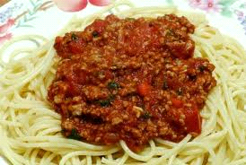

LUNCH: 11am to 2 pm Dinner: 4 pm to 7 pm

ADULTS $8.00 CHILDREN $4.00

4th AND SCHIFFERDECKER AVE.
JOPLIN, MISSOURI

PHONE: 417-623-5721 FAX: 417-623-1968
CARRYOUT AVAILABLE

We have Pecan Halves, Pecan Pieces and Chocolate covered pecans for sale

